Mike Finn
Real Estate Agency
106 S Main St, Virginia, IL 62691
217-452-3311 or 217-473-8033
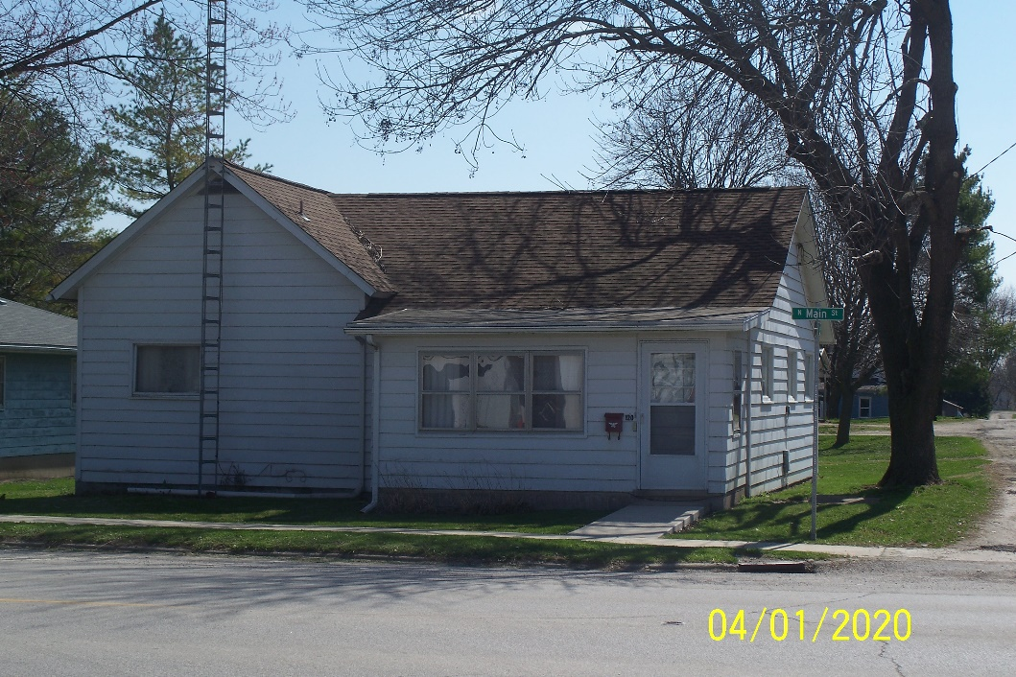

- 2 Bedroom
- Enclosed Porch
- 1 Car Unattached Garage
- Knotty Pine
- Central Air

LISTING | ADDRESS | CITY | PROPERTY TYPE | BEDROOMS | BATHROOMS | PRICE
Brown | 120 N Main | Virginia | Residential | 2 | 1 | $46,500
Construction | Age Built | Square Ft | Foundation | Condition | Garage | Lot Size
Frame |  | 1083 | Crawl | Good | Unattached 1 car | 60’x120’
Zoning | Taxes | Heat/Cool | Roof Age | School District | Average Utilities | Gas
Residential |  | Forced Air/Cent |  | Virginia
Water | Sewer | Water Heater | Windows | Insulation | Attic Fan | Fenced Yard
City | City
Paved Drive | Utility Shed | Storm Sewer | Refrigerator | Stove | Disposal | Washer/Dryer
No
Kitchen | Living | Family | Bedroom 1 | Bedroom 2 | Bedroom 3 | Fireplace
Bathroom 1 | Bathroom 2
“It is illegal to discriminate against any person because of race, color, religion, sex, handicap, familial status, or national origin.”

