Mike Finn
Real Estate Agency
106 S Main St, Virginia, IL 62691
217-452-3311 or 217-473-8033
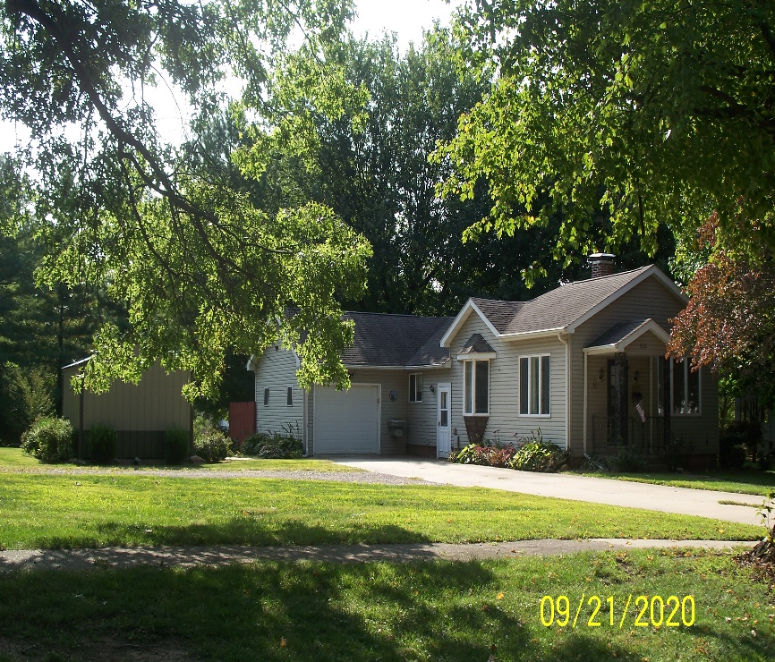
- 3 Bedroom 1 ½ Bath
- 1 car attached garage
- Nice Kitchen
- Deck
- Large Deep Lot

LISTING | ADDRESS | CITY | PROPERTY TYPE | BEDROOMS | BATHROOMS | PRICE
Petefish | 422 S Cass | Virginia | Residential | 3 | 1 | $78,500
Construction | Age Built | Square Ft | Foundation | Condition | Garage | Lot Size
Frame |  | 1554 | Basement | Good | 1 car garage | .5 acre
Zoning | Taxes | Heat/Cool | Roof Age | School District | Average Utilities | Gas
Residential |  | Forced Air/CA |  | Virginia |  | Ameren
Water | Sewer | Water Heater | Windows | Insulation | Attic Fan | Fenced Yard
City | City
Paved Drive | Utility Shed | Storm Sewer | Refrigerator | Stove | Disposal | Washer/ Dryer
Kitchen | Living | Family | Bedroom 1 | Bedroom 2 | Bedroom 3 | Fireplace
Bathroom 1
It is illegal to discriminate against any person because of race, color, religion, sex, handicap, familial status, or national origin.”

