Mike Finn
Real Estate Agency
106 S Main St, Virginia, IL 62691
217-452-3311 or 217-473-8033
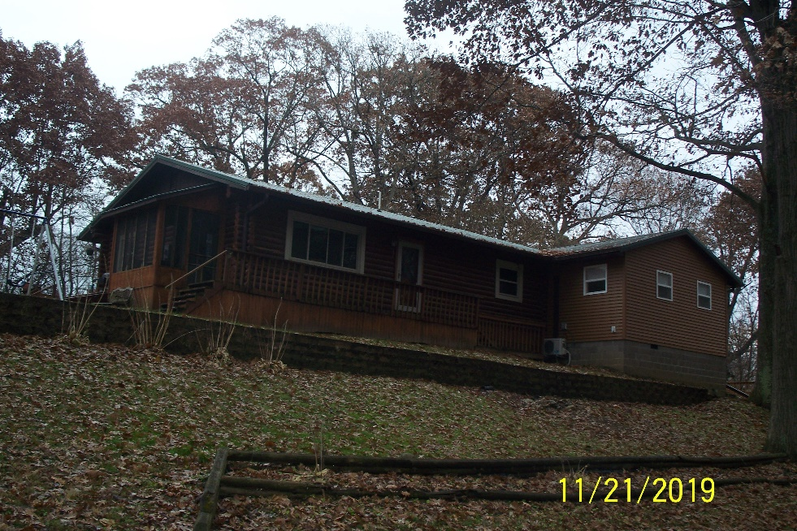

- 4 Bedroom 3 Bath
- Log Home
- 4.64 Acres
- Rural-Scenic View
- Deck
- Partially finished basement with 4th Bath

LISTING | ADDRESS | CITY | PROPERTY TYPE | BEDROOMS | BATHROOMS | PRICE
Winland | 6771 IL Rte 78 | Virginia | Residential | 4 | 3 | $179,000
Construction | Age Built | Square Ft | Foundation | Condition | Garage | Lot Size
Log | 1976/2016 | 1084/1000 | Basement | Good | 2 Car unattached | 4.64 Acre
Zoning | Taxes | Heat/Cool | Roof Age | School District | Average Utilities | Gas
Residential |  |  | Metal 3 years | Virginia |  | None
Water | Sewer | Water Heater | Windows | Insulation | Attic Fan | Fenced Yard
City | Septic
Paved Drive | Utility Shed | Storm Sewer | Refrigerator | Stove | Disposal | Washer/ Dryer
 |  |  | Optional | Optional |  | Optional
Kitchen | Living | Family | Bedroom 1 | Bedroom 2 | Bedroom 3 | Fireplace
 |  |  |  |  |  | None
Bathroom #1 | Bathroom #2 | Bedroom #4 | Bathroom #3
“It is illegal to discriminate against any person because of race, color, religion, sex, handicap, familial status, or national origin.”

