Mike Finn
Real Estate Agency
106 S Main St, Virginia, IL 62691
217-452-3311 or 217-473-8033
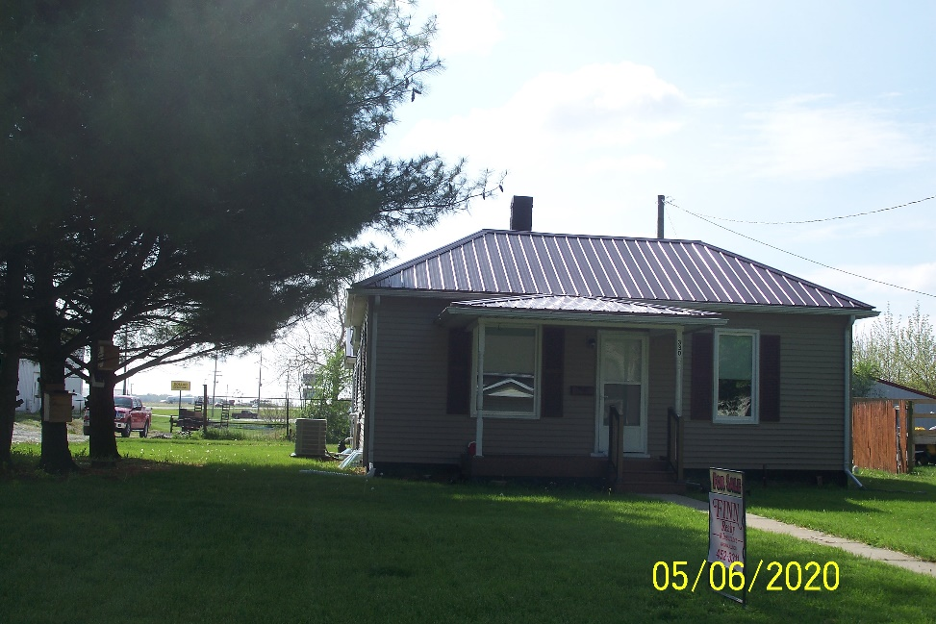
- 2 Bedroom 1 Bath
- 1 ½ car garage
- 760 sq. ft.
- 70’ x 120’ Lot
- Update in last year: Metal roof; windows; siding; flooring; shower; 95% furnace; Central Air; Countertop; Cabinets; microwave; dishwasher; stove; Frig and more.
LISTING | ADDRESS | CITY | PROPERTY TYPE | BEDROOMS | BATHROOMS | PRICE
Hamilton | 330 N Duncan | Virginia | Residential | 2 | 1 | $60,000
Construction | Age Built | Square Ft | Foundation | Condition | Garage | Lot Size
Frame |  | 760 | Basement | Good | Unattached 1.5 car | 70’x120’
Zoning | Taxes | Heat/Cool | Roof Age | School District | Average Utilities | Gas
Residential |  | Forced Air/CA 1 yr | 1 year Metal | Virginia | $107.00 | Ameren
Water | Sewer | Water Heater | Windows | Insulation | Attic Fan | Fenced Yard
City | City |  | New
Paved Drive | Utility Shed | Storm Sewer | Refrigerator | Stove | Disposal | Washer/ Dryer
 |  |  | New | New | New | Yes
Kitchen | Living | Family | Bedroom 1 | Bedroom 2 | Bedroom 3 | Fireplace
Bathroom 1
It is illegal to discriminate against any person because of race, color, religion, sex, handicap, familial status, or national origin.”

