Mike Finn
Real Estate Agency
106 S Main St, Virginia, IL 62691
217-452-3311 or 217-473-8033
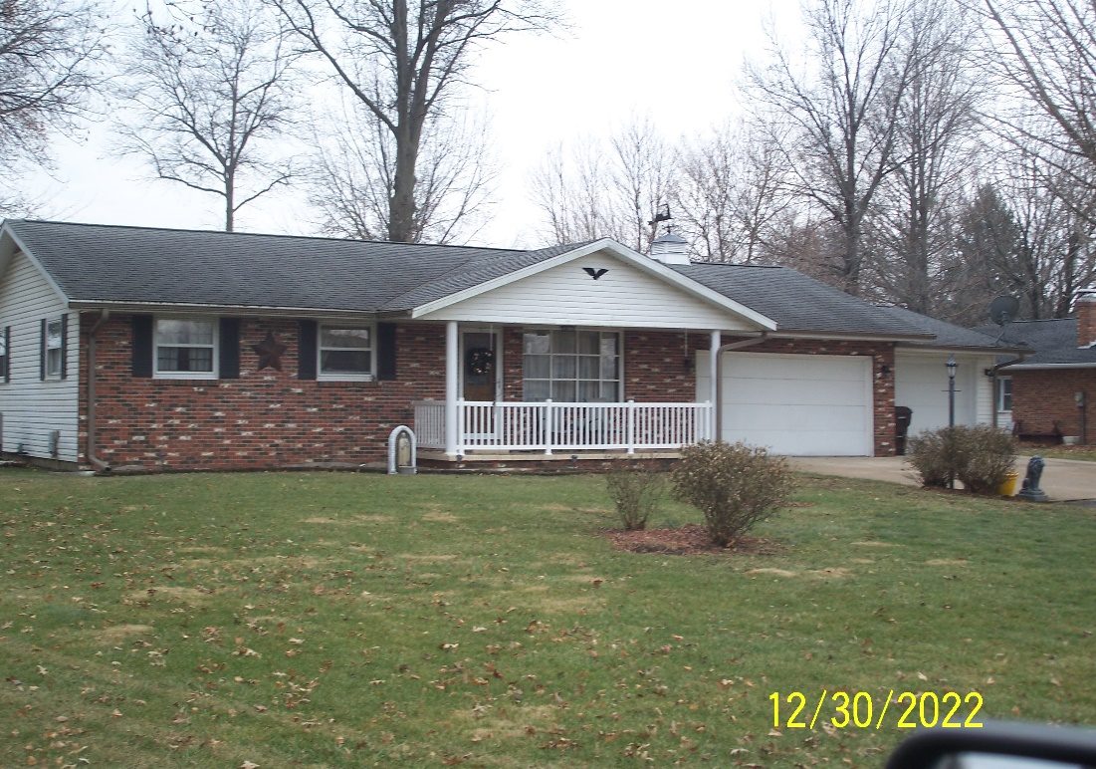
- 412 E Broadway, Virginia
- 3 Bedroom
- 2.5 Bath
- Heat Pump
- Central Air
- 3 Car Garage
- 96’ x 180’ Lot

LISTING | ADDRESS | CITY | PROPERTY TYPE | BEDROOMS | BATHROOMS | PRICE
Bachar | 412 E Broadway | Virginia | Residential | 3 | 2.5 | 159,500
Construction | Age Built | Square Ft | Foundation | Condition | Garage | Lot Size
Frame | 1975 | 1632 | Crawl | Good | 3 car Attached | 96’ x 160’
Zoning | Taxes | Heat/Cool | Roof Age | School District | Average Utilities | Gas
Residential |  | Heat Pump Central Air | 13 years | Virginia |  | None- all electric
Water | Sewer | Water Heater | Windows | Insulation | Attic Fan | Fenced Yard
City | City | Electric
Paved Drive | Utility Shed | Storm Sewer | Refrigerator | Stove | Disposal | Washer/ Dryer
“It is illegal to discriminate against any person because of race, color, religion, sex, handicap, familial status, or national origin.”

